INSTITUCION EDUCATIVA DEPTAL GUSTAVO URIBE RAMIREZ

GRANADA CUNDINAMARCA AÑO 2022

|  |  |
| --- | --- |
| NIVELACION INGLES 2022 | |
|  | |
| DOCENTE: IRENE AMAYA DOMINGUEZ | AREA, ASIGNATURA Y/0 DIMENSIÓN: INGLES |
| GRADO: OCTAVO | FECHA ELABORACION Y ENTREGA AL ESTUDIANTE  OCTUBRE 2022 |
| COMPETENCIA(S) NO ALCANZADA(S) | DESCRIPCION DE ACTIVIDADES A DESARROLLLAR |
| Comprende pequeños textos en presente simple:  Expone sus trabajos en forma oral y escrita.  El estudiante escribe y habla sobre sus gustos y preferencias.  El estudiante expresa en forma escrita y oral sus habilidades  Usa el conocimiento para anticiparse al contexto de las lecturas, además escribe mensajes cortos con propósitos en específico  .  -El estudiante escribe y habla sobre su país.  El estudiante escribe y habla sobre alimentos y desórdenes alimenticios.    -El estudiante expresa en forma escrita de forma sencilla sus opiniones en presente, pasado y futuro.  -Usa el conocimiento para anticiparse al contexto de las lecturas, además escribe mensajes cortos con propósitos en específico  Puede preguntar y responder a su profesora y compañeros en inglés (Yes/No and WH Q) | Función de la lengua.  -vocabulario y gramática: en la actividad encontrará, una caja de vocabulario que le servirá para resolverlas, es necesario que revise sus apuntes y haga uso del diccionario.  -textos discontinuos: debe observar y analizar de forma detallada las imágenes, leer y comprender las instrucciones y luego responder a preguntas, o unir, describir, etc.  comprensión lectora: primero debe leer el texto en inglés, hacer un reconocimiento global de la lectura, es decir, comprender el tema el vocabulario, el tiempo verbal etc., enseguida soluciona las actividades propuestas. En caso de tener dificultades haga uso diccionario    Apropiación de la lengua, aprendizaje u dominio de la lengua, en contexto. |
| CRITERIOS DE EVALIUACION  1.Solo se recibirán actividades en las fechas asignadas  Se deben entregar todas las actividades resueltas.  La parte escrita tiene un valor de 50%  4. la sustentación 50 % | FUENTES BIBLIOGRÁFICAS  http://enjoyenglish.free.fr/english/primaire/concentration/indoor/indoor.htm  <https://www.superteacherworksheets.com/graphing.html>  <https://www.tolearnenglish.com/>  http://enjoyenglish.free.fr/english/primaire/concentration/indoor/indoor.htm  www. Colombia aprende  way to go 8th student and workbook |
| ANEXOS (Guías – Talleres): | |
| FECHA DE ENTREGA  Septiembre 21 | FECHA DE ENTREGA DE EVIDENCIAS  OCTUBRE 10 de 2022 sustentación en a partir de el 16 de octubre |
| ESTUDIANTE | VALORACIÓN DOCENTE |
| Revisado Coordinación académica Maria Lucy Gutierrez | |

NIVELACIÓN INGLES GRADOS octavos

Theme

|  |  |  |
| --- | --- | --- |
| Subject 1st | Subject 2nd | Subject 3rd 4th |
| the animals and its habitat  Language Functions  • Talk about animals  • Describe places  • Identify cultural  characteristics  • Ask for and give information  about the habitats  Text Types:  descriptive paragraph,  advertisement, article | Language Functions  FOODS  Disorder health  Simple present  Past simple | Language Functions  Reading comprehension  Talking about the recipes and instructions  Present progressive  First conditional  Future |

TOPIC habitat animals

* 1. Actividades de Reflexión inicial.

1. Draw and write a description the jungle animal favorite

The Mountain Ecosystem

by Kimberly M. Hutmacher



A habitat is where a plant or animal lives and grow a habitat is part of an ecosystem where lots of different plants and animals live. Mountains, with their many levels are an ecosystem containing many different habitats.

At the base of a mountain, you will probably find a forest filled with lots of plants and trees. A grizzly bear or a garter snake might cross your path. You might catch a glimpse of an owl in a tree.

Climb higher, toward the middle of the mountainside and leave the forest behind for

grasslands and maybe a stream. Here, you might encounter a mountain lion stalking its prey or a salamander slipping underneath of a leaf to hide. Goats might be leaping from rock to rock.

Climb even higher, toward the top, and you'll notice a change in the temperature. It's getting colder and snow is covering the mountaintops. There aren't many plants near the mountaintop, but you might see fuzzy lichen covering rocks like carpeting. The air is thin at the top of the mountain, which makes it difficult for large animals to breathe. When people climb very large mountains, they often take special air tanks filled with oxygen. Even though you won't seen many big animals, millions of tiny insects like snow fleas might dot the landscape.

Depending on the elevation, you could see deserts, river valleys, meadows, forests and snow caps all on one mountain. And with each unique habitat, comes unique plant and animal life.

activities

1.define habitat

_____________________________________________________________________________

_____________________________________________________________________________

2. What happens as you climb higher and higher up a mountain?

* 1. You see more animals.
  2. The temperature rises.
  3. Forests become thicker.
  4. The temperature drop

3.What types of animals would you be most likely to see near the top of a mountain?

a. bears b. insects

c. owls d. There are no animals at the top.

4.What type of habitat would you would probably find at the base of a mountain?

_________________________________________________________

5.Why do you think most mountains do not have large lakes__________________________________________________________

6.

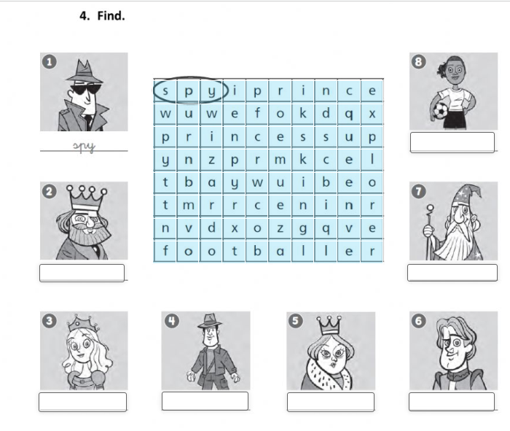

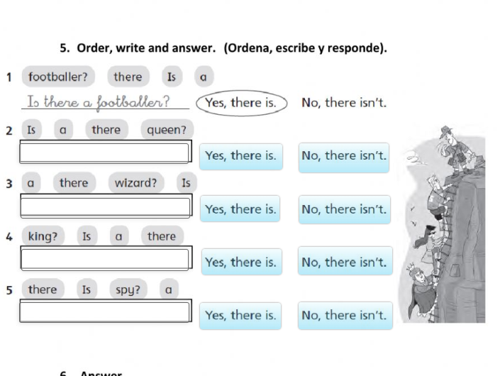

1. Completa las preguntas con ***was*** o ***were:*** Ejemplo:

Were you born in this city? No, I wasn´t. I was born in Monterrey.

* + - 1. ____________ you born in this city?
      2. When _________ you born?
      3. __________ your parents born here?
      4. When ________ your mother born?
      5. When_________ your father born?
      6. _________ you a good student in high school?
      7. What __________ your favorite subject?
      8. __________you good at sports?
      9. __________ you at math’s?
      10. Who ________ your first English teacher?

II. Consulta y contesta las siguientes preguntas:

* + 1. Were you on time for school today?

______________________________________

* + 1. Was your teacher absent yesterday?

_____________________________________

* + 1. When was the last time you went to the beach?

_____________________________

* + 1. Which was the last book you read?

_______________________________________

* + 1. Who was William Shakespeare?

_________________________________________

* + 1. When was the First World War?

__________________________________________

* + 1. What was the Titanic?

__________________________________________________

* + 1. Where were the1968 Olympic Games held?

________________________________

* + 1. Who was Leonardo DaVinci?

____________________________________________

* + 1. Where were The Beatles born?

___________________________________________

VII. Completa la siguiente conversación usando el pasado simple de los verbos en paréntesis

Beth: ¿Is there anything wrong, Anne? You look upset.

Anne: I think I (1) ____________ (fail) the chemistry exam. I (2) ____________ (study) hard for it, but I guess I (3) ______________ (not study) the right things. The professor

(4) ___________ (ask) really difficult questions.

Beth: I know. Tim and Joanna (5) ____________ (tell) me it (6) _________ (be) too hard. A lot of students (7) ­­­­_____________(complain) to Professor Harris. They

(8) ___________ (say) it was impossible.

Anne: It (9) _________ (be)! I (10) ____________(need) a good grade on the exam too, because my other test results (11) _________________ (not be) that good. By the way, how (12) _______ (be) your history exam?

Beth: We (13) _________ (have) 24 multiple choice questions and then we (14) _________

(write) two essay questions. I’m not sure how I (15) _________ (do) but I think I

(16) _________(pass) it. It (17) ____________ (not be) bad. But I like history and I

(18) ___________(spend) a lot of time on my homework.

Anne: Oh, here comes Jim! He just (19) _________ (have) the exam. Hi, Jim, how (20) ________ (be) your exam?

Jim: Would you believe that I (21) _________ (miss) it! I (22) ____________ (leave) home early this morning but the subway (23) __________(break) down in the Holland Tunnel and we (24) _____________ (be) stuck there for 35 minutes. What a bummer!

I have to make it up tomorrow.

Beth: That’s too bad. Well, let’s forget about exams right now and have some lunch.

I ’m hungry.

Lea el siguiente poema, y selecciona las respuestas para las preguntas.

***“A little gray kitten”,* By Shenya Gay**

A little gray kitten with big yellow eyes

Looked into a mirror with the greatest surprise

For there in the mirror and just the same size

Was a little gray kitten with big yellow eyes.

1. How many kittens were there?

a) One b) two c) more than two d) none

2. What was just the same size?

a) the kitten b) the eyes c) the surprise d) the mirror

3. How did the kitten react?

a) It doesn’t say b) It got angry c) It was happy d) It was amazed

4. What did the kitten see when it looked into the mirror?

a) nothing b) another kitten c) the greatest surprise d) itself

5. What size was the kitten?

a) It doesn’t say b) Just the same size c) Big d) Little

|  |  |  |  |  |  |  |  |  |  |  |  |  |  |  |  |  |  |
| --- | --- | --- | --- | --- | --- | --- | --- | --- | --- | --- | --- | --- | --- | --- | --- | --- | --- |
| **EJERCICIO** | | | |  |  |  |  |  |  |  |  |  |  |  |  |  |  |
| Observa el horario de Samira: | | | | | |  |  |  |  |  |  |  |  |  |  |  |  |
| SUNDAY |  | MONDAY | |  | TUESDAY | | |  | WED. | | THURSDAY | | FRIDAY | |  | SATURDAY |  |
| 1 |  | 2 |  |  | 3 |  |  |  | 4 |  | 5 |  | 6 |  |  | 7 |  |
|  |  | Labor day | |  |  |  |  |  |  |  |  |  |  |  |  |  |  |
|  |  | Holiday | |  |  |  |  |  |  |  |  |  |  |  |  |  |  |
| 8 |  | 9 |  |  | 10 |  |  |  | 11 |  | 12 |  | 13 |  |  | 14 |  |
|  |  |  |  |  | Music class | | |  |  |  | Dentist | 4:00 |  |  |  |  |  |
|  |  |  |  |  | 4:30 | |  |  |  |  |  |  |  |  |  |  |
|  |  |  |  |  |  |  |  |  |  |  |  |  |  |  |  |
| 15 |  | 16 |  |  | 17 |  |  |  | 18 |  | 19 |  | 20 |  |  | 21 |  |
| Church |  |  |  |  |  |  |  |  | tennis |  |  |  | Party Ed | |  |  |  |
| Dinner |  |  |  |  |  |  |  |  | game |  |  |  |  |  |  |  |  |
| 7:00 |  |  |  |  |  |  |  |  | 3:00 |  |  |  | 8:00 |  |  |  |  |
| 22 |  | 23 |  |  | 24 |  |  |  | 25 |  | 26 |  | 27 |  |  | 28 |  |
|  |  |  |  |  |  |  |  |  |  |  |  |  |  |  |  | hair |  |
| 29 |  | 30 |  |  | 31 |  |  |  |  |  |  |  |  |  |  | 10:00 |  |
|  |  |  |  |  |  |  |  |  |  |  |  |  |  |  |

Ahora haz preguntas sobre el horario de Samira y contéstalas. Siguiendo las siguientes instrucciones

Relice las m preguntas del dia 1 al dia 15 en presente simple y del día l6 al 30 realice las pdreguntas en pasado recuerde las regflas de conjugación y el uso de auxiliares do does para el presente y did y was or were para el pasado .

Hago uso de what, where, who, when, what time why

Ejemplo:

* When does Samir go to the dentist?
* She goes on Thursday 12th.
* What time does she go there?
* At four.

______________________________________________________________

______________________________________________________________

______________________________________________________________

______________________________________________________________

______________________________________________________________

______________________________________________________________

______________________________________________________________

Lea el siguiente texto y responda a las pdreguntas

**FOODS**

Foods made from grains (wheat, rice, and oats) help form the foundation of a nutritious diet. They provide vitamins, minerals, carbohydrates (starch and dietary fiber), and other substances that are important for good health. Grain products are low in fat, unless fat is added in processing, in preparation, or at the table. Whole grains differ from refined grains in the amount of fiber and nutrients they provide, and different whole grain foods differ in nutrient content, so choose a variety of whole and enriched grains. Eating plenty of whole grains, such as whole wheat bread or oatmeal, as part of the healthful eating patterns described by these guidelines, may help protect you against many chronic diseases. Aim for at least 6 servings of grain products per day more if you are an older child or teenager, an adult man, or an active woman and include several servings of whole grain foods. For serving sizes.

Vitamins, minerals, fiber, and other protective substances in whole grain foods contribute to the health benefits of whole grains. Refined grains are low in fiber and in the protective substances that accompany fiber. Eating plenty of fiber-containing foods, such as whole grains (and also many fruits and vegetables) promotes proper bowel function. The high fiber content of many whole grains may also help you to feel full with fewer calories. Fiber is best obtained from foods like whole grains, fruits, and vegetables rather than from fiber supplements for several reasons: there are many types of fiber, the composition of fiber is poorly understood, and other protective substances accompany fiber in foods. Use the Nutrition Facts Label to help choose grains that are rich in fiber and low in saturated fat and sodium.

1. What types of carbohydrates does grain provided the body with?

2. Why does a teenager require more grain than an adult?

3. Why are you often told to eat products that are high in fiber?

Prueba oral-

1.Elaboré un poster sobre un a región de Colombia, tenga en cuenta: ubicación, platos típicos, atuendo típico, folclor.

Seleccione alguno de los trastornos alimenticios y realice una corta exposición en ingles tenga en cuenta:

Causas

Síntomas

Tratamiento

Recomendaciones

Seleccione un vegetal de su preferencia y realice un folleto donde se explique los nutrientes, para que se utiliza y ¿cuáles son las ventajas de consumirlo?. Recuerde la actividad que se realizo acerca del tomate.